**Breton, André (1896-1966)**

Anne Cunningham

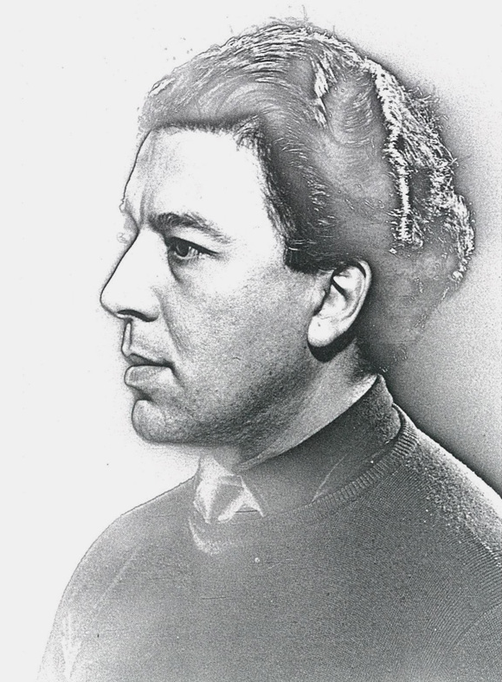

Breton in 1929

Photo: Man Ray  
http://www.fondationbeyeler.ch/en/exhibitions/surrealism/biographies

**Summary**

André Breton was a French poet, writer, editor and critic. He is best known as one of the key founders of Surrealism. Breton published the *Le Manifeste du Surréalisme*(*The Manifesto of Surrealism*) in 1924, announcing the central theme of the pre-eminence of the irrational and the automatic over logic and reason, encouraging free expression and the release of the subconscious mind in an effort to reject and overthrow social and moral conventions. Influenced by Sigmund Freud’s theories of the unconscious, Surrealism sought to blur the distinctions between dream and reality, reason and madness, objectivity and subjectivity. Breton was a strict disciplinarian within the movement, expelling many members, and was nicknamed ‘The Pope of Surrealism.’ Breton’s other well known works of fiction include *Nadja* (1928) and *L’Amour fou* (1937 *Mad Love*). During World War Two, Breton’s writing was banned by the Vichy government, and he fled France until 1946 when he returned to Paris. He was an avid collector of modern art, ethnographic materials, and unusual objects. His collection of over 5,300 pieces was open to researchers at his Paris apartment after his death in 1966 until 2003, but was closed after attempts to form a surrealist foundation failed, and his collection was auctioned off. A wall of his apartment is preserved today at the Centre Georges Pompidou.

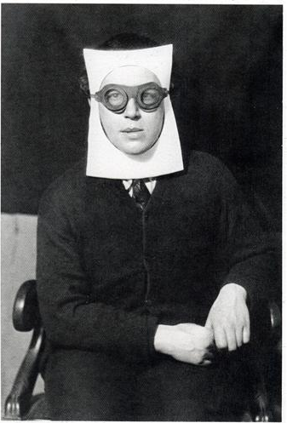

**Photo By Man Ray**

**http://www.wikiart.org/en/man-ray/andr%C3%A9-breton-1930**

**Main Entry**

Breton was born in 1896 in Normandy. He attended medical school, where he became interested in mental illness and Freud’s psychoanalytic theory; he met Freud in 1921. During World War One, Breton worked in a neurological ward in Nantes where we met Jacques Vaché, a devotee of the French Symbolist writer Alfred Jarry. In 1916, Breton moved to Paris where he joined the avant-garde. In Paris he met other aspiring writers and artists who shared his interests, including Guillame Apollinaire. Influenced greatly by Symbolists poets Arthur Rimbaud and Charles Baudelaire, the political theory of Karl Marx, and Freud, he joined the group of artists who were part of the subversive Dada movement, including Marcel Duchamp and Man Ray. The French branch of the Dada movement formed around the periodical *Littérature* that was co-founded by Louis Aragon, Philippe Soupault, and Breton in 1919. It contained Breton and Soupault’s ‘Les Champs Magnétiques’ (‘Magnetic Fields’), the first example of the Surrealist technique of automatism. The Parisian branch of the Dadaists sponsored a number of exhibitions, public art shows, provocations, and publications, but lasted only four years. The group soon split into to two factions, Tristan Tzara leading the radical Zurich branch of Dadaists, and Breton and his friends remaining in Paris to resurface under the new name of the Surrealists.

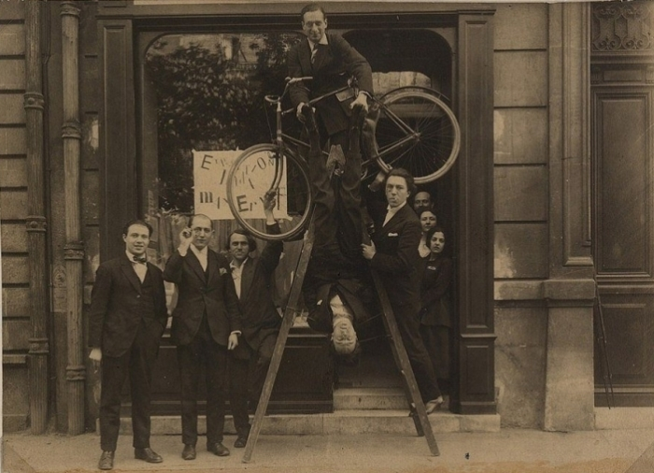

**Opening of the Max Ernst exhibition at the gallery Au Sans Pareil, May 2, 1921.  
From left to right: René Hilsum, Benjamin Péret, Serge Charchoune, Philippe Soupault on top of the ladder with a bicycle under his arm, Jacques Rigaut (upside down), André Breton and Simone Kahn.**

**http://www.dadart.com/dadaism/dada/024-dada-paris.html**

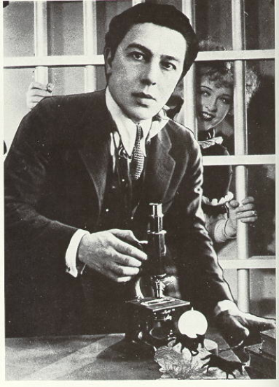

#### Photo: André Breton, self-portrait Automatic Writing (1938),

#### The Vera and Arturo Schwarz Collection of Dada and Surrealist Art at the Israel Museum, Jerusalem

After the Paris Dada group split, Breton shifted his allegiance to a group of intellectuals who would become known as the Surrealists. In 1924, he published the first of three manifestos: *Le Manifeste du Surréalisme*(*The Manifesto of Surrealism*). The manifesto announced the new movement’s embrace of liberated expression and rejection of social, moral, and aesthetic conventions. Central to Surrealism was automatism, a technique developed to draw on the unconscious without any intervention on the part of the critical faculties, avoiding rational thought as much as possible. Automatism excludes reason, moral and aesthetic judgment from the creative process in order to express the functioning of thought, what Breton termed ‘pure psychic automatism.’ Automatism is fundamental to Surrealism. For Breton, automatism proposed a means for artists to free themselves from the constraints of the rational mind and cultural preconceptions to make art in an immediate manner. Breton’s most significant theoretical book on automatism is *The Automatic Message* (1933).

In 1924, the Bureau central de recherches surréalistes (Central office of Surrealist Research) opened in Paris, and the first issue of *La Révolution surréaliste*  (*The Surrealist Revolution*) was published in December of that year, not long after Breton’s first manifesto. *La Révolution surréaliste* distanced itself from the conventional literary world. The first three issues abandoned the rubric of poems, and contributions consisted of ‘dreams,’ ‘surrealist texts,’ ‘essays,’ and ‘reports.’ To clarify their aims, the Surrealists issued the ‘Déclaration du 27 janvier 1925’ which emphasized their revolutionary goals, insisting that Surrealism was not a poetic form.

Significantly, paintings were included only after Breton assumed editorial control in 1925 when reproductions of paintings by Max Ernst, Joan Miró, Pablo Picasso, and others supplemented drawings and photographs. Breton also wrote ‘Le surréalisme et la peinture’ (‘Surrealism and Painting’) which discussed the importance of Picasso from a Surrealist perspective. By the time the sixth issue appeared in 1925, the Surrealist movement had undergone significant political transformation. In 1926 the publication of a pamphlet by Pierre Naville, ‘Intellectuals and the Revolution: What Can the Surrealists Do?,’ prompted a debate over Surrealism’s political position. Naville challenged the Surrealists to join the Parti communiste français (PCF). Although Breton responded by criticizing the PCF’s literary policies while also defending the Surrealists’s right to pursue their work outside of ideological constraints, Naville’s critique resonated with the movement. Breton, Louis Aragon, Paul Éluard, and other important Surrealists joined the PCF in 1927. Yet Breton’s membership was subject to intense scrutiny because of his criticisms, and he would leave the PCF.

Breton’s second *Deuxième Manifeste du surréalisme* (The Second Surrealist Manifesto) appeared in the final issue of the journal in 1929. The political impasse of Surrealism is evident in the polemical tone. Breton not only restated the aims of Surrealism but also called former Surrealists into account. For Breton, the cultural and political dimensions of Surrealism could only be maintained within the confines of a disciplined elite group, and he called for the ‘occultation’ of Surrealism, replacing former Surrealists with Salvador Dalí, René Magritte, Luis Buñuel, and René Char. A new journal, *Le Surréalisme au service de la révolution (Surrealism in the service of the revolution)* replaced *La Révolution surréaliste*, and six issues were published between 1930 and 1933. Although it was during this time Surrealism lost its primacy on political radicalism among cultural groups, Breton maintained it was the most balanced and inspired of all the Surrealist magazines.

Breton published other surrealist texts including *Les Vases Communicants*(*The Communicating Vessels* 1932) and *Qu'est-ce le que le Surréalisme?*(*What is Surrealism?* 1934). He also wrote poetry and fiction. One of his most well known works of fiction,*Nadja* (1928), is a surrealist love story between the narrator and a mysterious woman.*L'Amour Fou*(*Mad Love* 1938) is a poetic meditation on obsessive love.

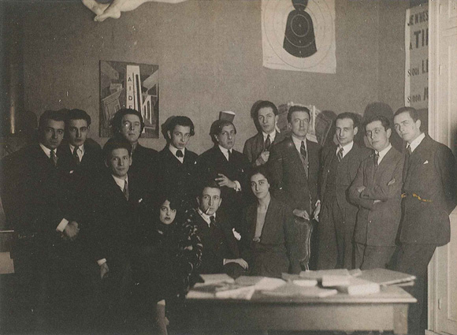

Members of the *Bureau central de recherches surréalistes*, 1924

Standing: Jacques Baron, Raymond Queneau, Pierre Naville, André Breton, Jacques-André Boiffard, Giorgio de Chirico, Roger Vitrac, Paul Eluard, Philippe Soupault, Robert Desnos, Louis Aragon; seated: Simone Breton, Max Morise, Marie-Louise Soupault

Photo by Man Ray http://www.fondationbeyeler.ch/en/exhibitions/surrealism/biographies

Breton broke with the PCF in disgust with Stalinism and Moscow show trials, yet he remained committed to Marxist philosophy. In 1938, he accepted a cultural commission from the French government to travel to Mexico. During this trip he collaborated with the revolutionary leader Leon Trotsky to write ‘Manifesto pour un art révolutionnaire independent’ (‘Manifesto for an Independent Revolutionary Art’) which examines art's connection to social upheaval.

During the German occupation of France, the Vichy Government banned his writing, and Breton fled to the United States and the Caribbean along with other Artists, including Duchamp and Man Ray. In 1942 at Yale University he organized a Surrealist exposition. Breton returned to France in 1946, where, the following year, he produced another Surrealist exhibition.

By the end of World War Two, Breton decided to explicitly embrace anarchism. Breton consistently supported the francophone Anarchist Federation and the Federation Communiste Libertaire.

During the 1940s and 50s, Breton worked on essays and poems, and published *Constellations* (1959) a suite of poems inspired by Miró’s gouache paintings of the same name. Breton also collected art; his collection contained over 5,300 items of modern paintings, drawings, sculptures, photographs, books, journals, and indigenous and ethnographic art. His collection remained intact and open to researchers until 2003, when it was dismantled and sold at auction.

Breton was married three times to Simone Kahn; Jacqueline Lamba, with whom he had a daughter named Aube; and Elisa Claro. He died in Paris on September 28, 1966 at the age of 70.

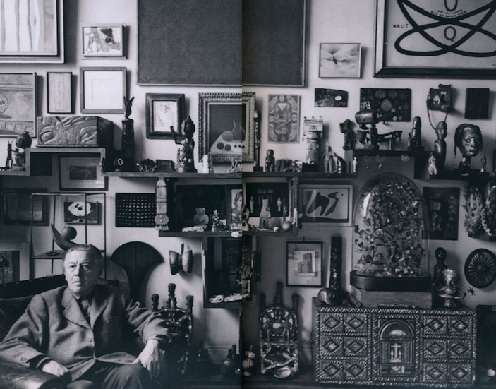

André Breton's portaits by Ida Kar, 1960. National Portrait Gallery, London.

**List of Selected Works**

Mont de piété (1919)   
S'il Vous Plaît (1920 – If You Please)   
Les Champs magnétiques (1920 – The Magnetic Fields)   
Manifeste du surréalisme (1924 – The Surrealist Manifesto)   
Les Pas perdus (Breton) (1924 – The Lost Steps)   
Poisson soluble (1924 – Soluble Fish) –novel  
Un Cadavre (1924 -- A Corpse)   
Légitime Défense (1926 – Legitimate Defense)   
Le Surréalisme et la peinture (1926 – Surrealism and Painting)   
Nadja (1928 – Nadja)   
L'Immaculée Conception (1930 – The Immaculate Conception)   
Deuxième Manifeste du surréalisme (1930 – The Second Manifesto of Surrealism)   
Ralentir travaux (1930 – Slow Down Works)   
L'Union libre (1931)   
La Revolver à cheveux blancs (1932 – The Revolver Has White Hair)   
Les Vases communicants (1932 – The Communicating Vessels)   
Le Message automatique (1933 – The Automatic Message)   
Qu'est-ce que le surréalisme (1934 – What Is Surrealism)   
L'Air de l'eau (1934 – Looks Like Water)   
Point du Jour (1934 – Break of Day)   
Position politique du surréalisme (1935 – The Political Position of Surrealism)   
Notes sur la poésie (1936 -with Paul Éluard – Notes on Poetry)   
L'Amour fou (1937 – Mad Love)   
Point du jour (1937)   
Dictionnaire abrégé du surréalisme (1938 --with Paul Éluard – Abridged) Dictionary of Surrealism   
Manifesto for an Independent Revolutionary Art (1938 -with Leon Trotsky)   
Fata Morgana (1940)   
Anthologie de l'humour noir (1940 – Anthology of Black Humor)   
Arcane 17 (1945 – Arcane 17)   
Jeunes Cerisiers garantis contre les lièvres (1946 – Young Cherry Trees Secured against Hares)   
Ode à Charles Fourier (1947 – Ode to Charles Fourier)   
Yves Tanguy (1947)   
Poèmes 1919–48 (1948)   
La Lampe dans l'horloge (1948 – The Lamp in the Clock)   
Martinique, charmeuse de serpents (1948)   
Entretiens, (1952 – Discussions)   
La Clé des champs (1953 – The Key of the Fields)   
Farouche à quatre feuilles (1954 with Lise Deharme, Julien Gracq, Jean Tardieu – Wild to Four Leaves)   
Les Manifestes du surréalisme (1955 – Manifestoes of Surrealism)   
L'Art magique (1957 – The Magic Art)   
Constellations (1958)   
Le la (1961)   
Selected Poems (1969)   
Perspective cavalière (1970)   
What is Surrealism? Selected Poems (1978)   
Poems of André Breton (1982)

Breton: Oeuvres complètes, tome 1 – (1988 Breton: The Complete Works, tome 1)

Breton : Oeuvres complètes, tome 2 – (1992 Breton: The Complete Works, tome 2)

Breton : Oeuvres complètes, tome 3 – (1999 Breton: The Complete Works, tome 3)

**Further Reading**

Bru, Sascha Ed. (2006) *The Invention of Politics in the European Avant-garde (1906-1940)*, Amsterdam: Rodopi.

Caws, Mary Ann (1971, rev. 1996) *André Breton*, New York: Twayne Publishers.

---(1970) *The Poetry of Dada and Surrealism: Aragon, Breton, Tzara, Eluard, Desnos,* Princeton: Princeton UP.

Durozoi, Gerard (2004) *History of the Surrealist Movement*, Princeton: Princeton UP.

Polizzotti, Mark (2009) *Revolution of the Mind: The Life of André Breton*, Boston: Commonwealth Books.